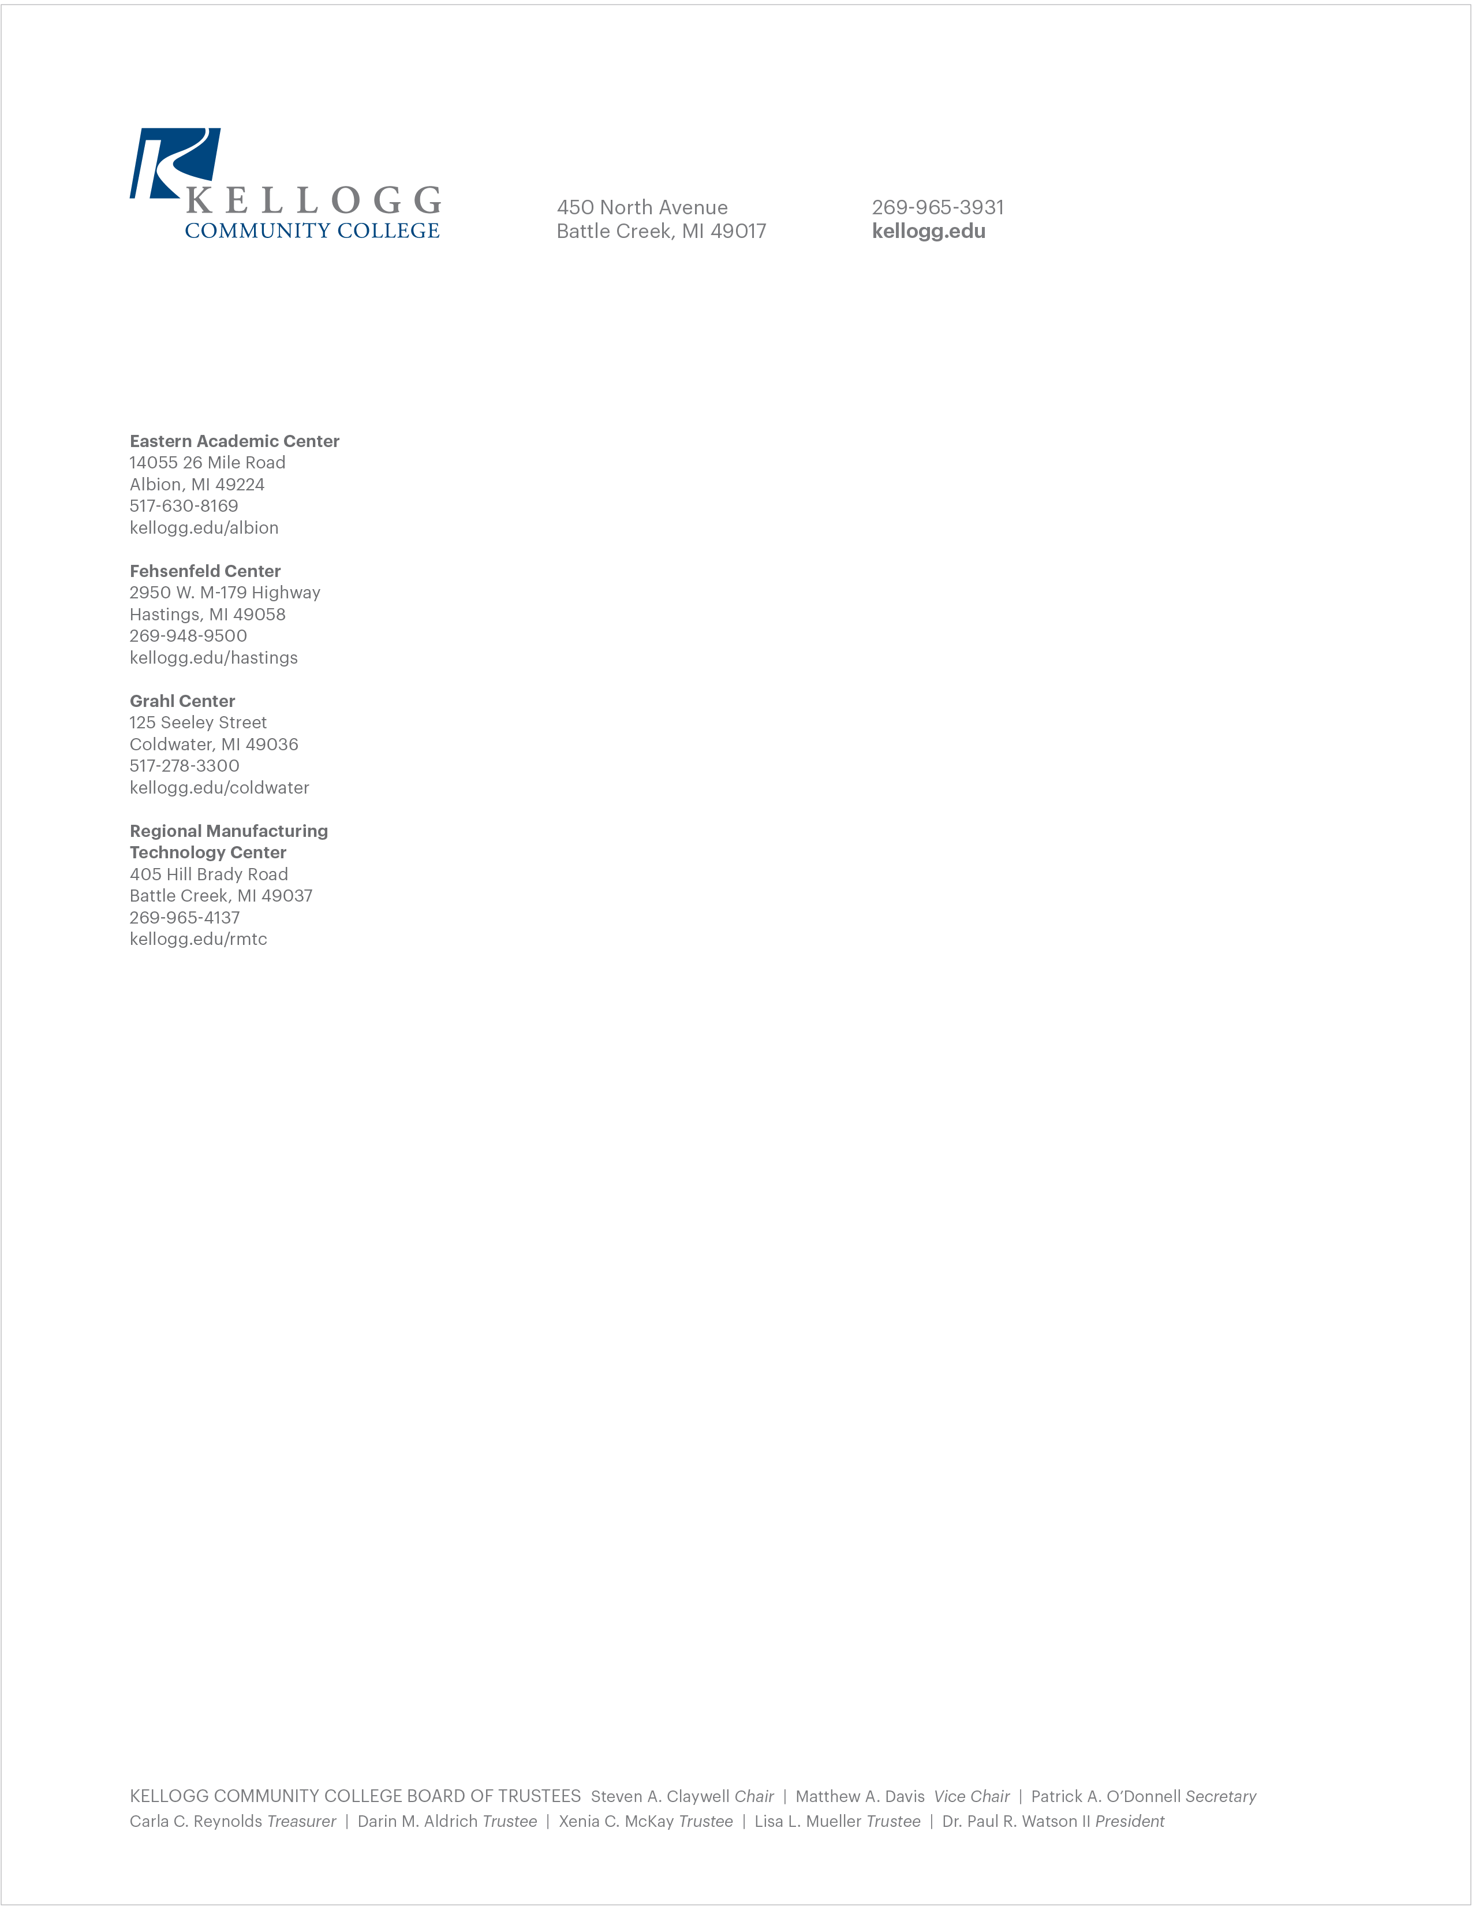

Campus Hazing Transparency Report
2024-2025

Hazing Reports
Kellogg Community College is committed to maintaining a safe and respectful environment for all students. Hazing in any form is strictly prohibited under Michigan law (“Garret’s Law”) and federal law.

No Findings of Responsibility for Hazing Violations:

07/01/2025 - 11/30/2025
12/01/2025 - 4/30/2026

- Reported hazing incidents: 0
- Investigations initiated: 0
- Confirmed violations of KCC’s hazing policy: 0

The absence of reported incidents this year reflects our continued commitment to education, prevention, and compliance with state and federal law.

KCC continues to monitor and enforce its policies to ensure the safety and well-being of all students.

Policies and Resources
KCC’s policies, reporting procedures, and educational resources regarding hazing are available online:

Hazing Information

Students, staff, and community members are encouraged to review these resources to stay informed and help maintain a safe campus environment.

