How to Schedule A Make-up & Online Test

1. Select “Center for Student Success” from the “Current Student” drop-down menu on the KCC homepage

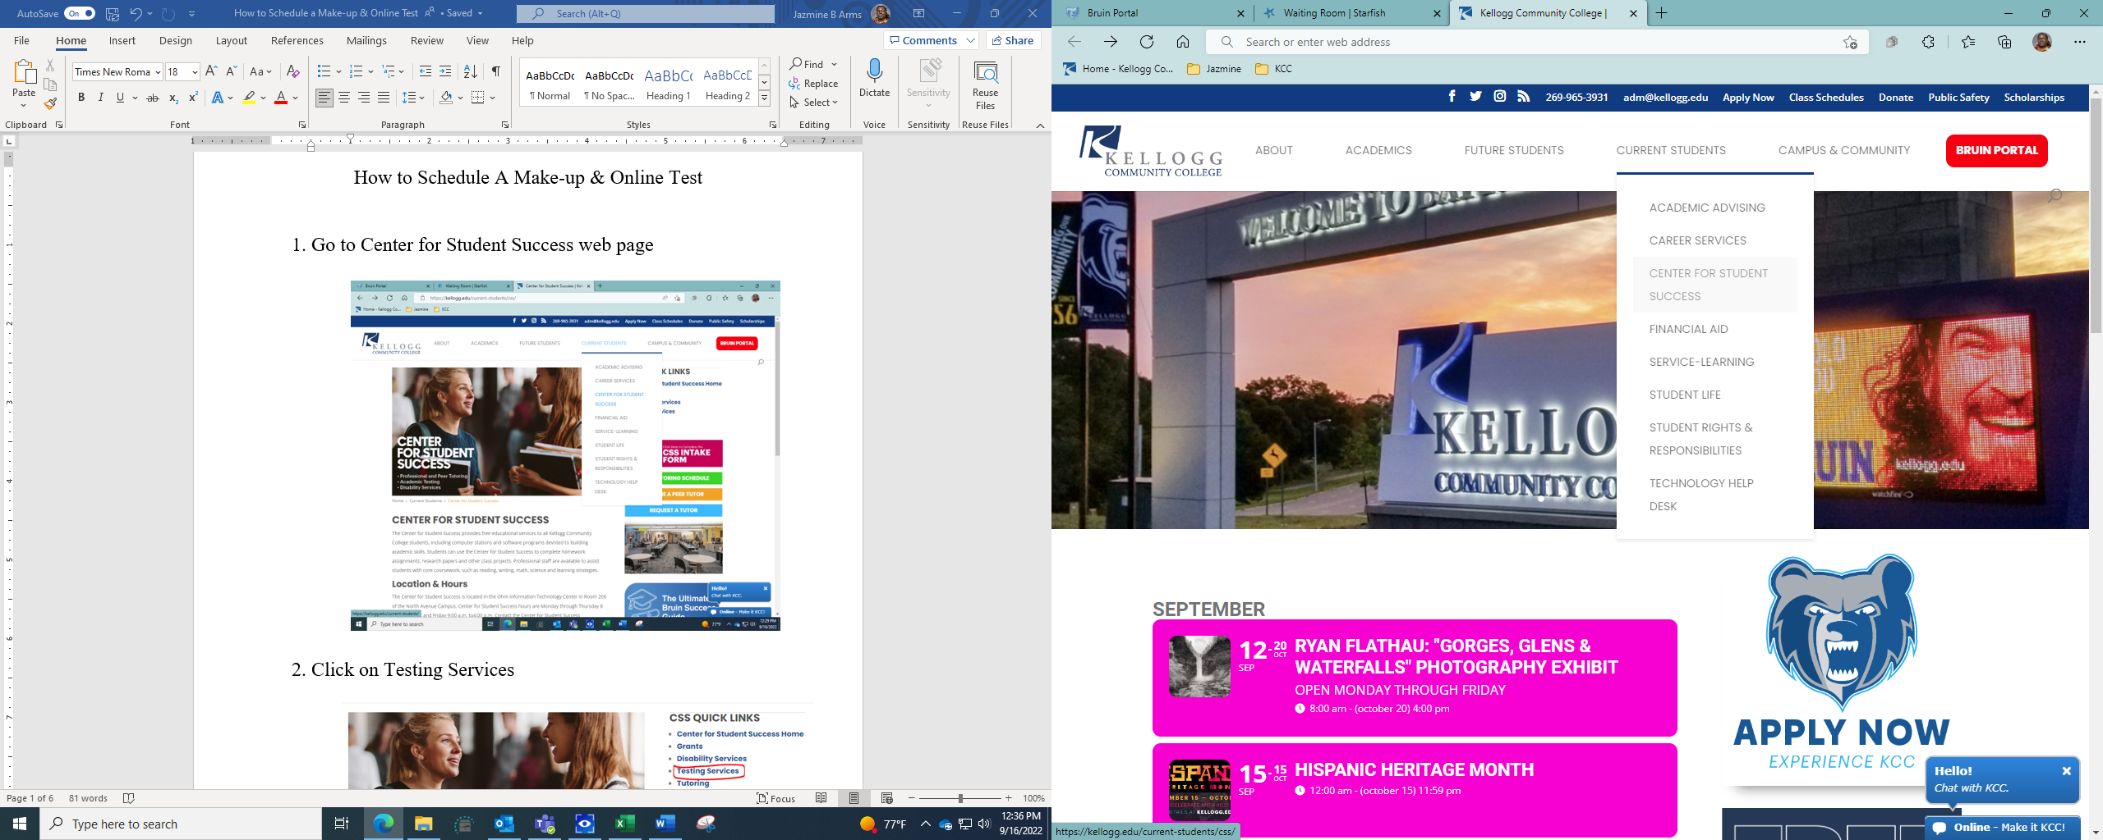

1. Click on Testing Services

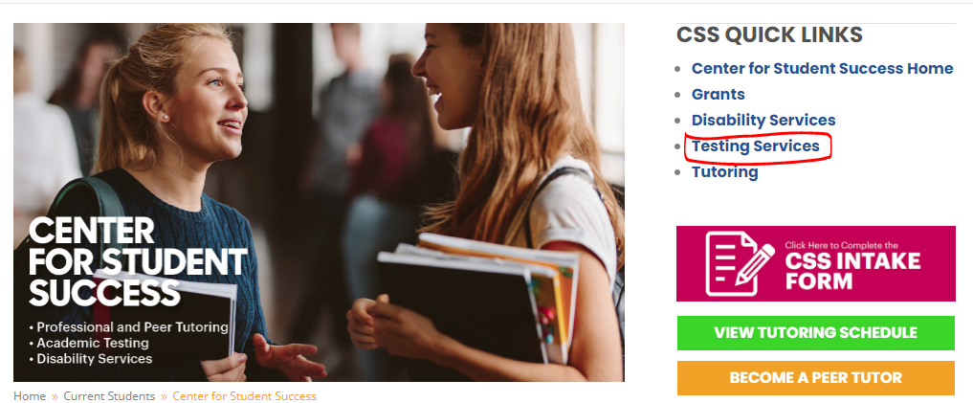

1. Click on Make-Up and online testing

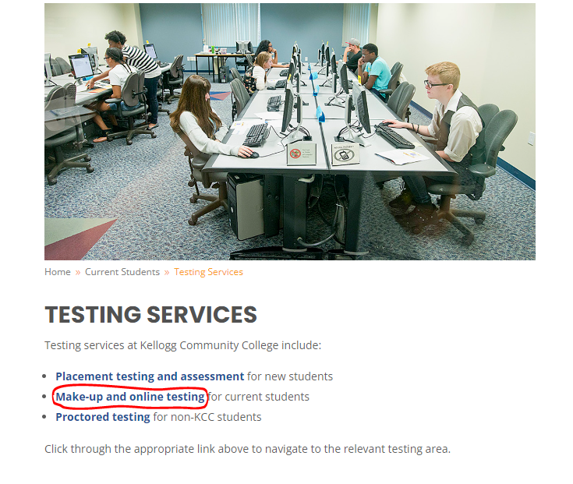

1. Choose your Testing Location

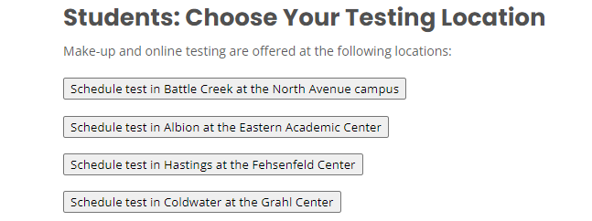

1. Select Take a Test

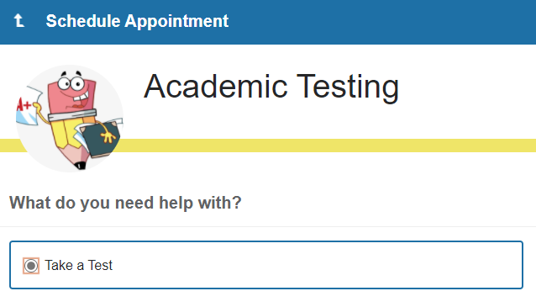

Select Continue

1. Select your appointment Date and Time

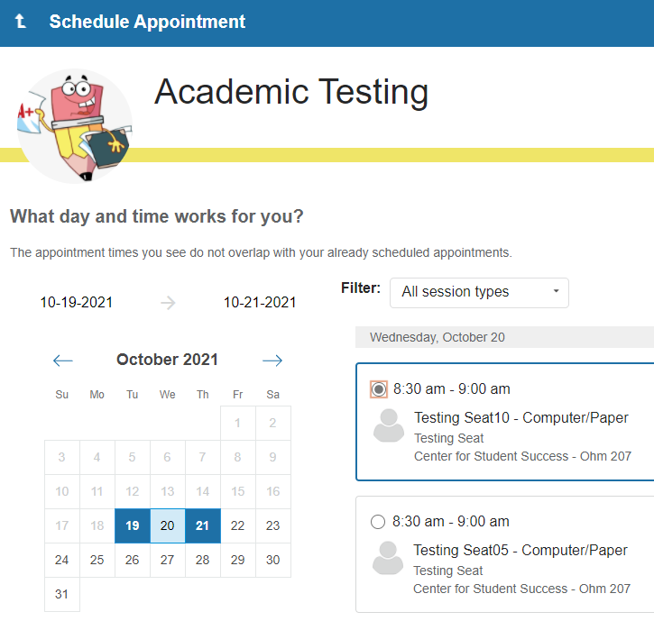

Select Continue

1. Testing duration

* Select Change Duration

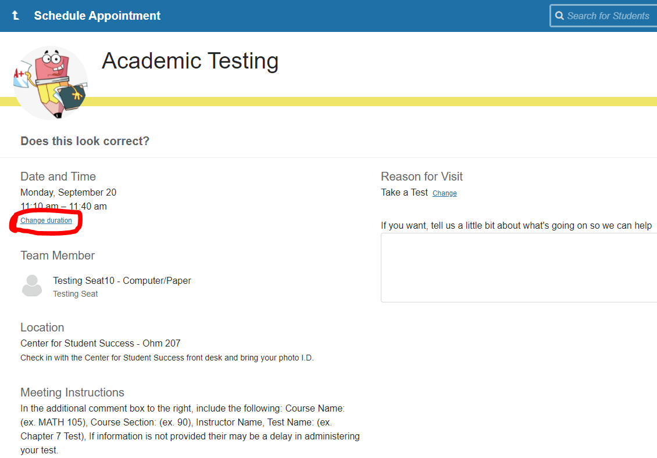

* Select appropriate time length

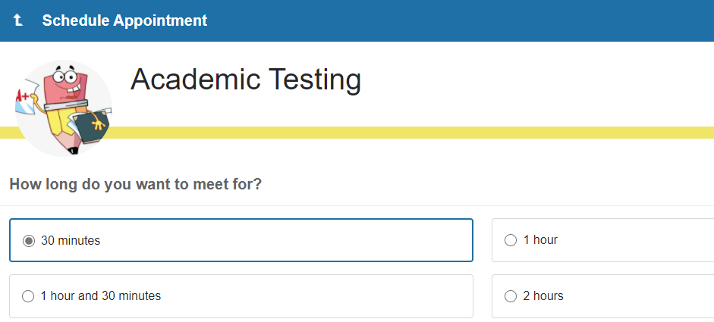

1. Meeting Instructions

* Additional information box
* ADD: Course Name, Section Number, Instructor Name, & Test Name

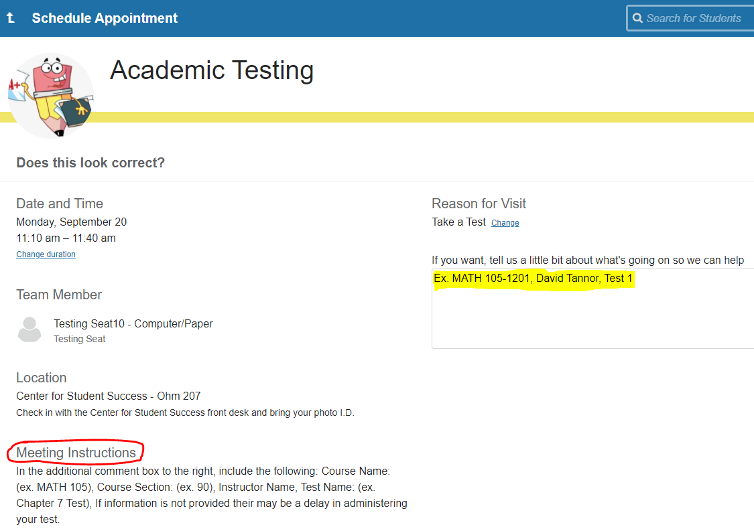



Select Confirm